1.Create Log Analytic Workspace

1.Select Subscription: Prod01

2.Resource Group: Prod01-rg

3. Select: Pro01-rg

4.Select: Create Log Analytic Workspace

5.Name: Prod01-Log-analytics

6.Tag-Prod02 value-1

7.Click on Create

2.Diagnostoc Setting Creation.

Go to Home->prod subscription->Resource group->Select application gateway->select ->Diagnostic settings->select diagnostic settings name:- Prod01-Logs-Analytics->Logs check the Box->Send to Logs Analytics check the box then save. As shown below image for reference.

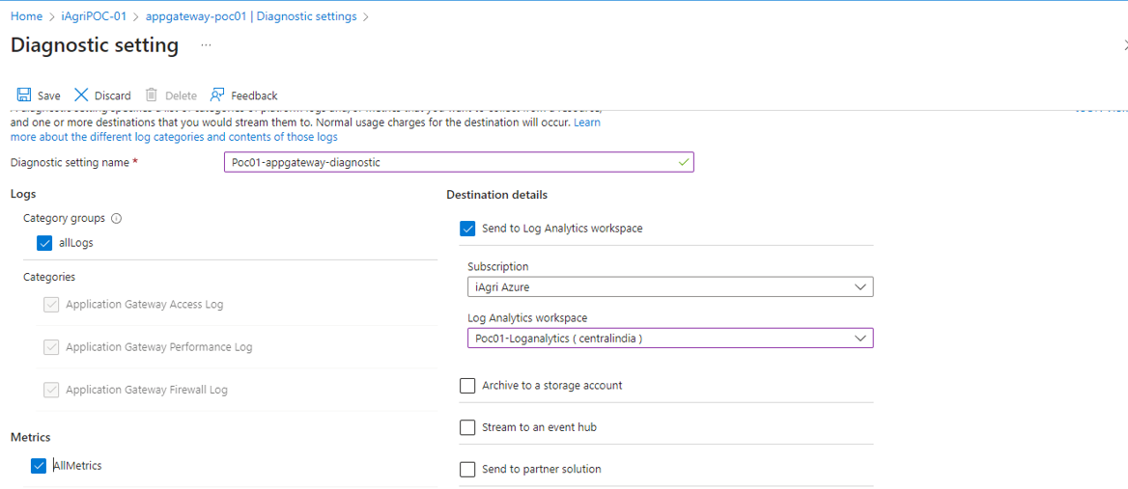

3.How to check Logs

Go to Home 🡪select Prod01🡪select Resource Group🡪Prod01-rg🡪select prod01-rg-appgateway🡪here left panel click on LOGS🡪Click on Alerts, select here which we want to RUN or run below customized query.

Query 1

AzureDiagnostics  
| where ResourceType == "APPLICATIONGATEWAYS"   
    and OperationName == "ApplicationGatewayAccess"  
    and StatusCode == "200"

Query 2

AzureDiagnostics  
| where ResourceType == "APPLICATIONGATEWAYS"  
    and Category == "Application Gateway Firewall Log"

Query 3

AzureDiagnostics  
| where ResourceType == "APPLICATIONGATEWAYS"  
  and OperationName == "ApplicationGatewayAccess"  
  and httpStatus_d == 200

Create PGSQL Flexible Server Logs.

Go to Home 🡪select Prod01🡪select Resource Group🡪Prod01-rg🡪select pgsqldatabase 🡪select left side LOGs🡪select any query enter below query and run.

Query1

AzureDiagnostics

| top 50 by TimeGenerated desc

Query2

AzureDiagnostics

| take 50

Generate Active Logs from PGSQL Data base.

Take database server name: - iagridbpoc01.postgres.database.azure.com

Login in to pgAdmin.

Select Database🡪Postgres right click 🡪select create Script🡪Query. (Reference image is below)

Pgsql database script Query’s:

1. SELECT * FROM pg_stat_activity WHERE state = 'active';
2. SELECT * FROM pg_stat_activity;